**First Reconciliation and First Eucharist**

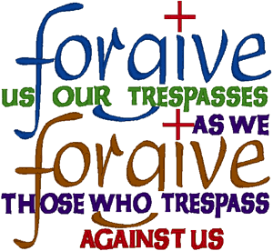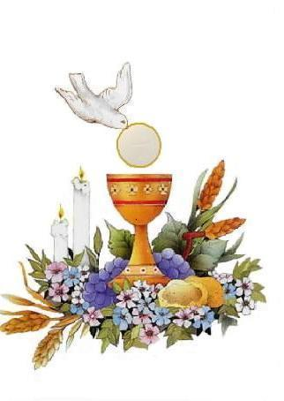

**Registration Forms**

**Good Shepherd Cluster**

**Sacramental Prep. Registration Form (One Per Student!)**

**Annual Waiver**

**Materials Fee**

**Consent Forms**

**Volunteer Opportunities Sheet**

**Copy of Baptismal Certificate (If NOT Baptized in the Good Shepherd Cluster Parishes).**

**Good Shepherd Cluster, Sacramental Programs**

**Registration 2025-2026**

*(Please fill out one form for each individual student enrolling in Sacrament Preparation)*

**Student Information:**

Student's Full Name: _____________________________________________________________________________

Date of Birth: ______________________Grade: _____ Family Email: _______________________________________

Family Home Phone: ____________________ Cell Phone: _______________________________________________

Mailing Address: ________________________________________________________________________________

**Parent Information:**

Father's Full Name: ________________________________________________Religion: _______________________

Address (if different): ______________________________________________Phone: _________________________

Mother's Full Name (Plus Maiden): ___________________________________Religion: ________________________

Address (if different): ______________________________________________Phone: __________________________

**Sacraments Student is Registering For:**

First Reconciliation and First Eucharist: _____

Confirmation: _______

**Prerequisites:**

It is a parish policy that a student wishing to begin Sacramental Preparation must have been enrolled in either Catholic School or Faith Formation at least **one year prior to beginning their preparation.** Please indicate where your son/daughter has attended either Catholic School or Faith Formation during the 2022-2023 school year here: ____________________________________________________________________________________________

**Previous Sacraments:**

Please indicate where your son/daughter has received:

Baptism: _________________________________________________________________________________________

Parish Name City/State Date

**If other than the Good Shepherd Cluster, please include a copy of their Baptismal Certificate**

Eucharist: ________________________________________________________________________________________

Parish Name: City/State Date

Reconciliation: ____________________________________________________________________________________

Parish Name: City/State Date

**Materials Fee: Please make checks out to the Good Shepherd Cluster!**

**First Reconciliation/First Eucharist: $55.00**

**Confirmation: $25 One-time payment in grade 10 or 11**

**Your materials fee must be paid in full when you turn in your registration. The *Materials fee will be processed totally separate from Faith Formation/St. John’s Tuition.* If you have a student in our Wednesday Night Faith Formation or St. John’s Program, you will need to write a separate check for any Sacrament Materials fees. Return registrations by August 25th, 2025, to the Good Shepherd Parish Office. Financial Aid is available upon request.**



For Business Office:

Total Students Registered: ________________ Date Payment Received: ____________

Total Materials Fee Due: __________________ Check #: __________________________

Does your child (children) enrolled in Sacramental Preparation have chronic illnesses or physical limitations?

Yes No

Does your child (children) have any type of learning difficulty?

Yes No

**If YES to either of these questions:** please describe on the lines below:





______________________________________________________________________________

Please indicate the level of prior Faith Formation training or Catholic School and any other information you feel would help us in working with your child/children and include a **copy of each child's Baptismal Certificate:**





**______________________________________________________________________________**

**Section 3: Consent Forms:**

**MEDIA RELEASE AND AUTHORIZATION**

|  |
| --- |
| I understand that by signing this Release and Authorization I hereby grant authority to  Good Shepherd Cluster for the use of any videotapes, photographs, or similar items in which my child/children might appear, or statements made by them, in the production, display, or sale of public service announcements.  Parent/Guardian signature __________________________________ Date_____________ |

**Annual Consent Form/Liability Waiver:** Please make sure to fill out a separate annual consent form (additional sheet in packet) **for each student.**

**I authorize the following to pick up my children (any non-parent/guardians who plans to pick up the children MUST be listed): _____________________________________________________________________________**

**______________________________________________________________________________**

**______________________________________________________________________________**